Mobile App for Direct

Market Access for

Farmers

**PROBLEM STATEMENT:**

Farmers often struggle to access markets directly, leading to reliance on intermediaries who reduce their income by capturing a significant share of profits. This dependence on middlemen limits farmers' ability to sell produce at fair prices, impacting their livelihoods and economic stability. Additionally, the lack of direct market access creates inefficiencies and reduces transparency in the supply chain, inflating costs for consumers. Addressing this issue is essential to empower farmers, ensuring they receive fair compensation and fostering a more equitable and efficient agricultural marketplace.

**Team Leader Name**: **S. MURALIKARTHIK**

# ABSTRACT

This project tackles the issue faced by farmers who often struggle to access markets directly, resulting in their reliance on intermediaries that significantly reduce their income. These middlemen capture a substantial share of the profits, limiting farmers' ability to sell their produce at fair prices and affecting their economic stability. The proposed solution is "AgriConnect," a mobile application designed to bridge this market gap by connecting farmers directly with consumers and retailers.

The app will feature capabilities for listing produce, negotiating prices, and managing transactions, thereby reducing dependence on intermediaries. By offering farmers direct market access, AgriConnect aims to ensure fair pricing, enhance income potential, and create a more transparent and efficient agricultural supply chain.

This solution seeks to improve farmers' economic conditions and foster a more equitable marketplace, benefiting both producers and consumers through better communication and reduced costs. AgriConnect has the potential to revolutionize the agricultural sector by empowering farmers and streamlining the supply chain.

**We want to implement by using below Softwares:**

1. KOTLIN
2. FIREBASE
3. XML
4. JAVA
5. CSS
6. FIGMA
7. FLUTTER

# FLOWCHART:

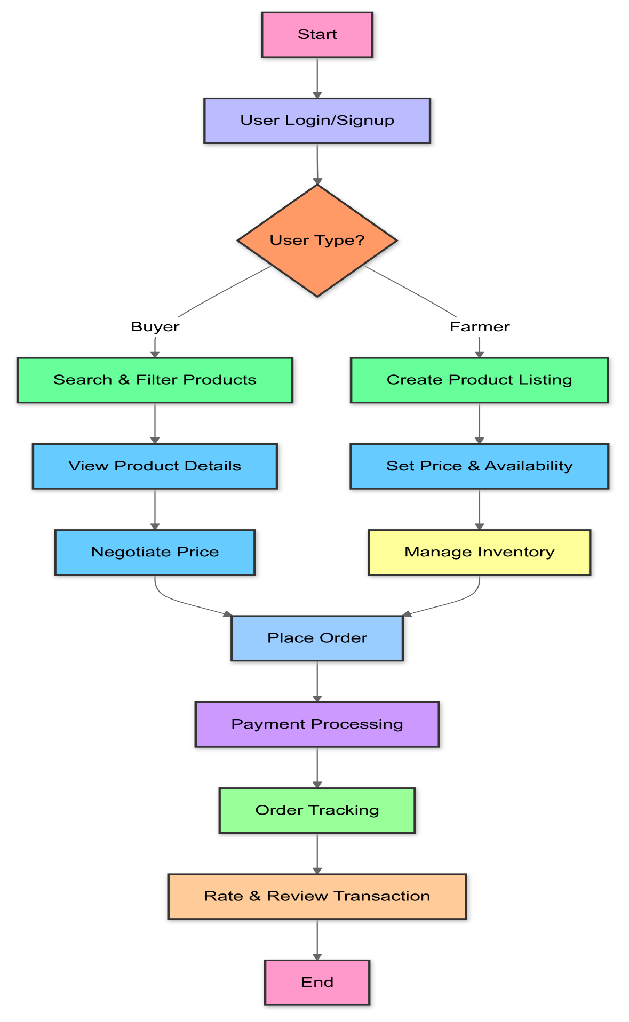

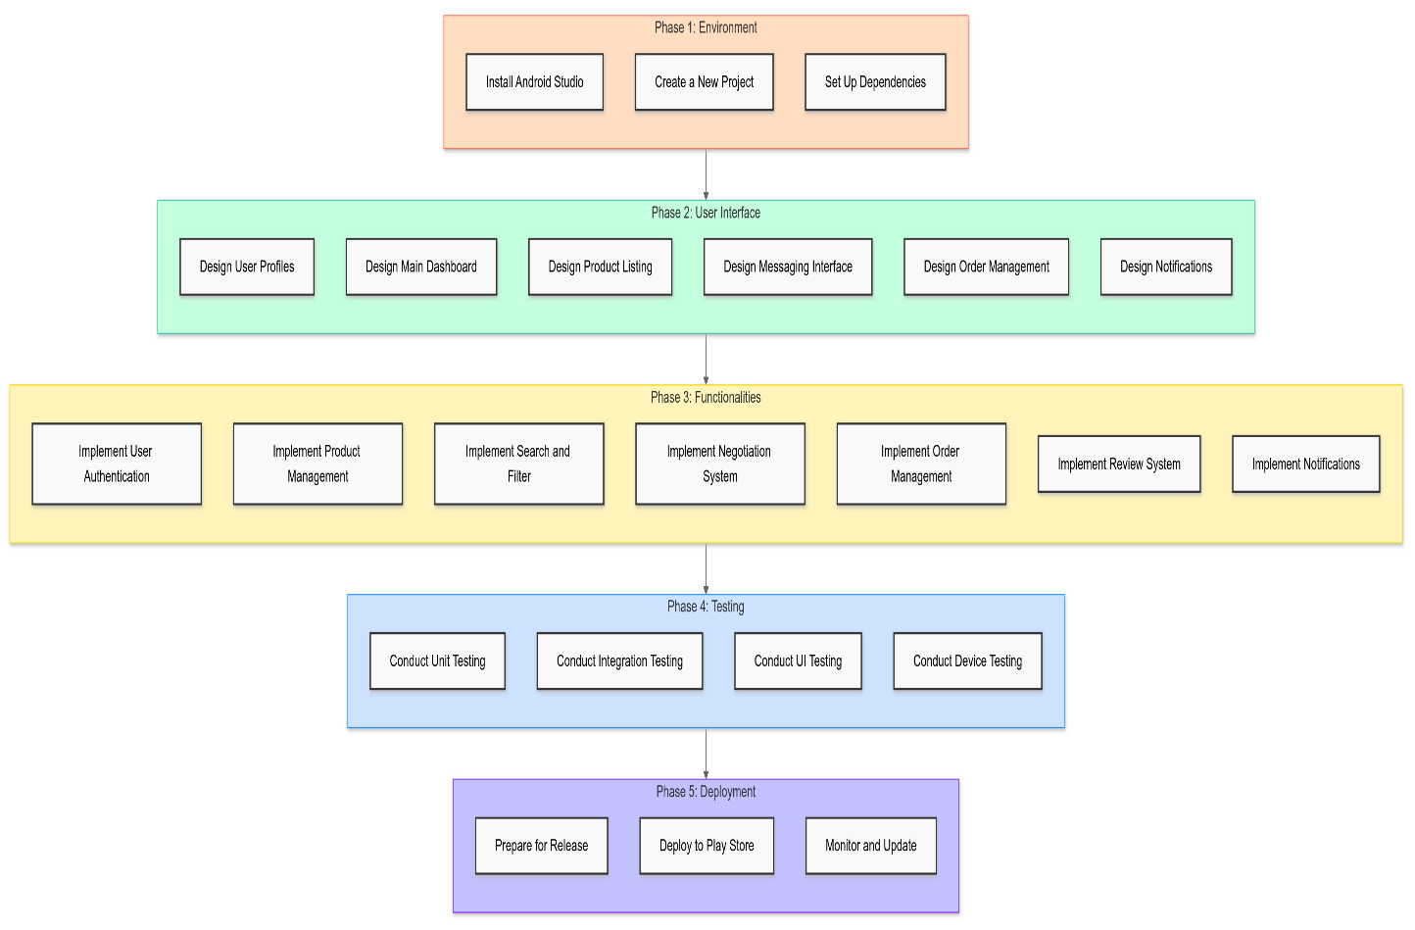

PHASES IN THIS APP DEVELOPMENT